Marketplace Open Enrollment Checklist
Get ready to sign up for health insurance!
Section 1: Before Your Visit
- Create or update your HealthCare.gov account
- If you already have an account, bring your username and password.
- If you forgot your login, reset your password before your appointment.
- If you’re new, visit HealthCare.gov and click “Create Account.”
  - Follow the step-by-step instructions at the bottom of this checklist to help with setup.
Section 2: Carry the following for your Visit

Bring Your Information
- Names, birthdays, and relationships of everyone in your household
- Social Security Numbers (if you have them)
- Income info (pay stubs, W-2, tax return, unemployment)
- Current insurance cards (if any)
- Immigration documents (if applicable)

2. Know Your Household
- How many people are claimed on your tax return?
- Who will need coverage?

3. Your Coverage
- Are you uninsured?
- Do you have Medicaid, CHIP, Medicare, or employer insurance?

4. Health Plan Preferences
- Do you have any preferred doctors or clinics?
- Do you take prescription medications?
- Preferred plan type: PPO, EPO?

5. Choose the plan
- We can review available plans with you, but we cannot choose or recommend a plan.
- We encourage you to choose a plan before your appointment to make the process smoother and quicker.
- For more guidance, please refer to our “How to Browse Plans on HealthCare.gov” and “Health Insurance Guide” for detailed information.

Section 3: After Your Visit
- Prepare to pay your plan before January 1, 2026.
- Ensure the premium amount is deducted from your bank account.
- If you don’t receive a bill, contact the insurance company directly and provide your HealthCare.gov application number.
- Take home a copy of your chosen plan and submission confirmation.

Step-by-Step instructions on creating an account on healthcare.gov
- Go to HealthCare.gov.
- Click “Login” in the top right corner.
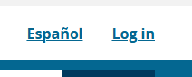

- Click “Create Account.”
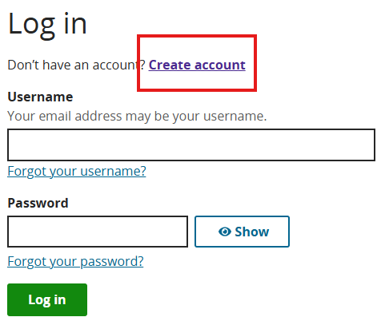
- Select your state of residence (e.g., Alaska).
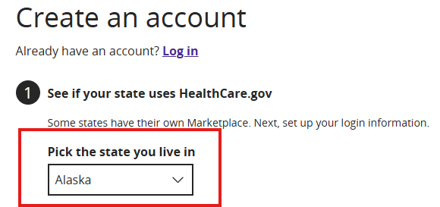

- Enter your first and last name, email address, and create a password.
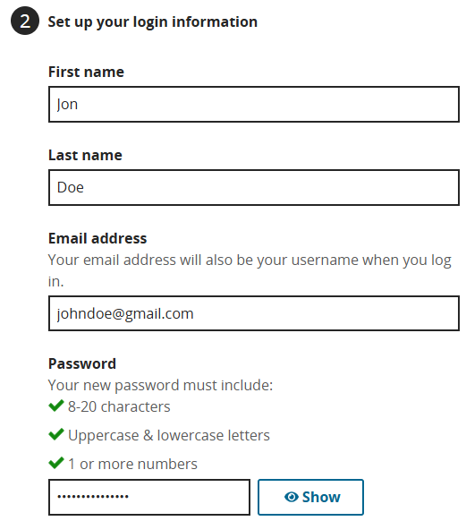
- Pick 3 security questions (only you know the answers — helps if you forget your password).
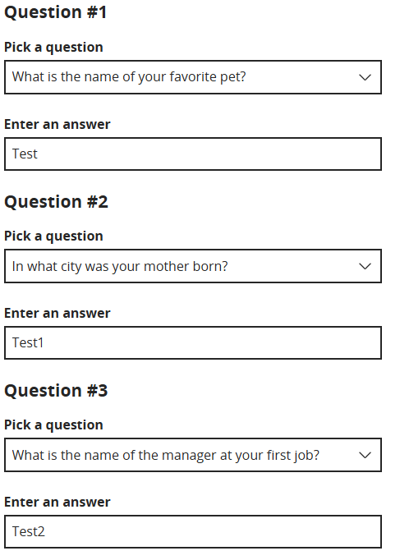

- Check “I understand and agree” and click “Create Account.”
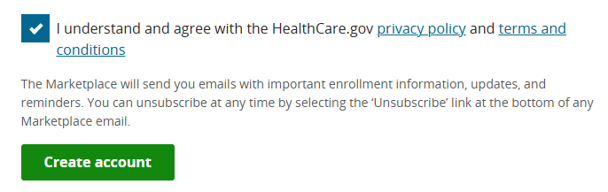
- You will receive an email from Health Insurance Marketplace notices@healthcare.gov to verify your email.
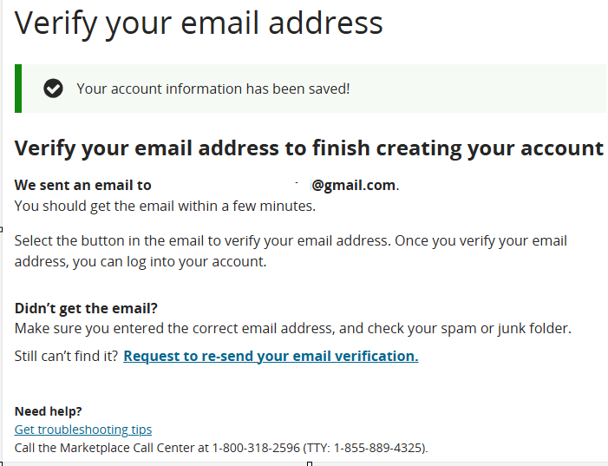
- Open the email and click the “Verify my email address” link.
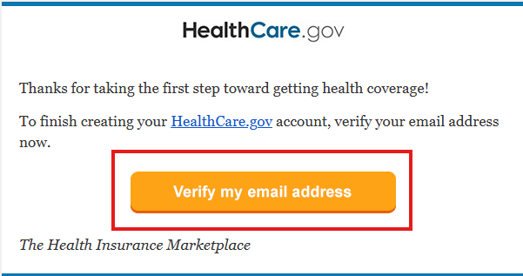

- After verification, return to HealthCare.gov and click “Login.”
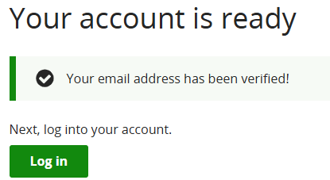
- Enter your email and password.
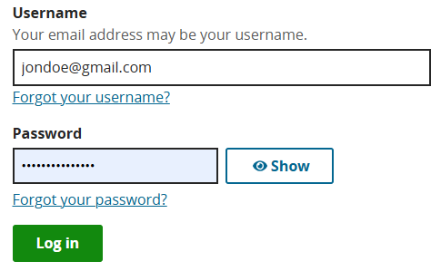
- You may be prompted to set up two-step verification. You can complete it now or click “Set up later.”

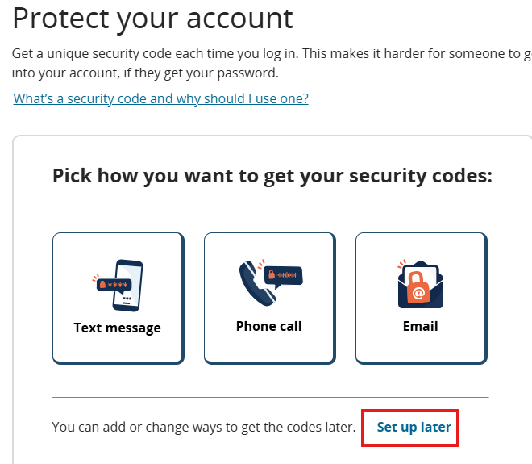

- You will see a welcome message. Click “Manage Account Settings” to verify your identity.

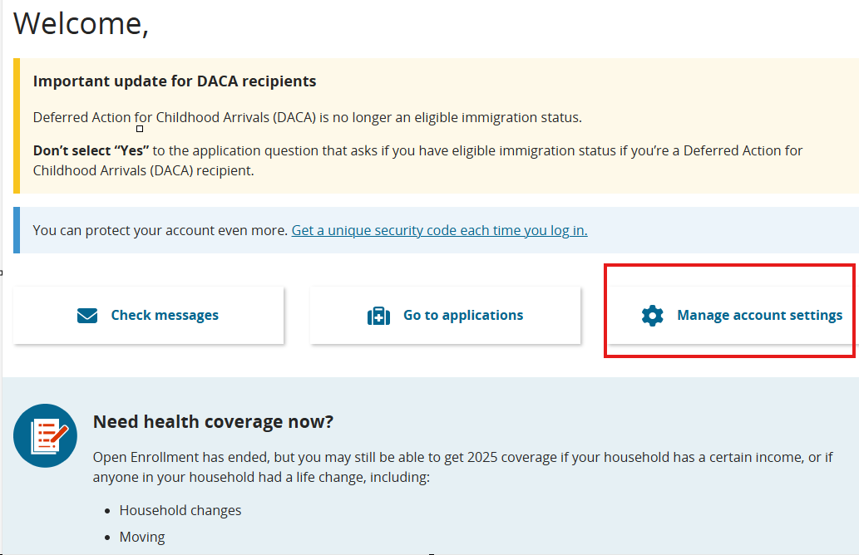
- Click “Verify Now”
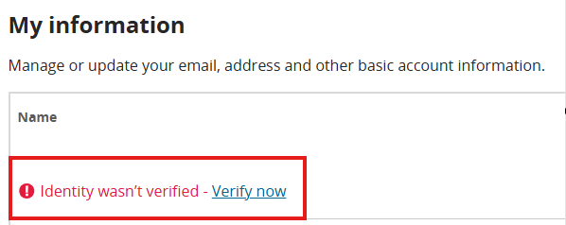

- You will be asked to enter:
  - Date of birth
  - Social Security Number
  - Home address
  - Phone number
Once entered Click “Agree and Continue.”
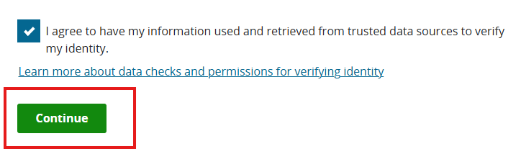
- Verification may happen immediately or take some time. Once verified, you’ll see a confirmation message.
