How to Browse Health Plans on HealthCare.gov
You can look at plans available on HealthCare.gov without creating an account. This helps you get an idea of prices, savings, and coverage options before you apply.

Step 1: Go to HealthCare.gov
- Open your web browser and go to: www.healthcare.gov
- On the home page, look to the right side of the screen. You’ll see several options — click on “Browse plans & costs.”

Note: The website is currently showing 2025 plans. Plans for 2026 will be available in mid-November.

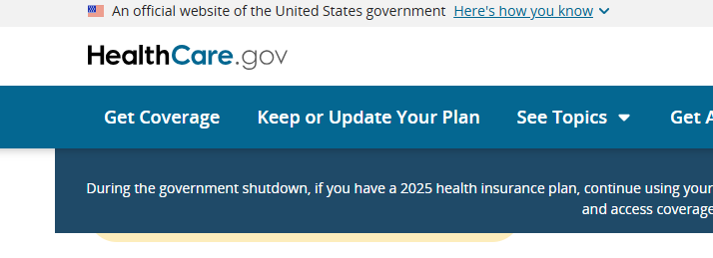
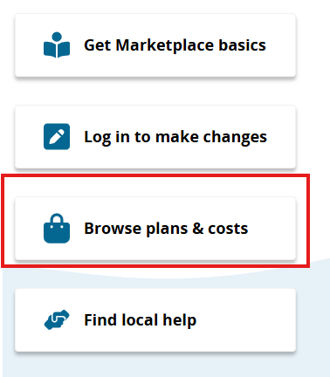

Step 2: Enter Your ZIP Code
- You’ll be asked to enter your ZIP code.
- Type your ZIP code in the box — for example: 99503.
- A dropdown will appear (for example, Anchorage County). Select the correct area and click Continue.
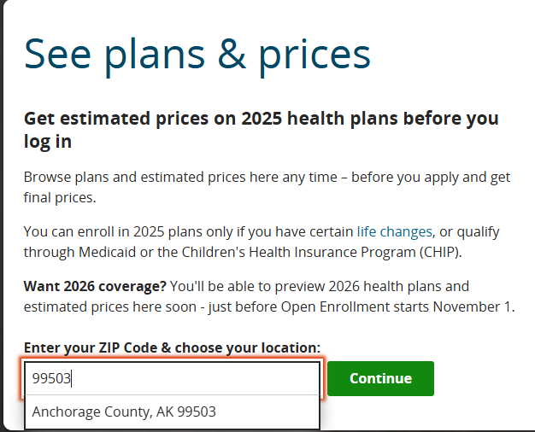

Step 3: Choose How You Want to See Plans
There are two ways to browse plans:

- Enter your personal details (age, household size, income, etc.)
  - This gives you a more accurate estimate of your premium tax credits (savings).
  - You’ll see plans and prices tailored to your household and income.
  - By answering a few questions, you'll see prices based on your age, household, and income. These prices may be much lower than prices without this information.

- See full prices without entering personal details
  - Click on “See full prices.”
  - This shows sample prices based on a 35-year-old with no savings applied.

Tip: It’s best to enter your information so you can see your real estimated savings. The steps below will show you how to do that.

Step 4: Enter Your Household Information
Click Start to answer a few questions about your household. This helps HealthCare.gov show the plans and savings available to you.
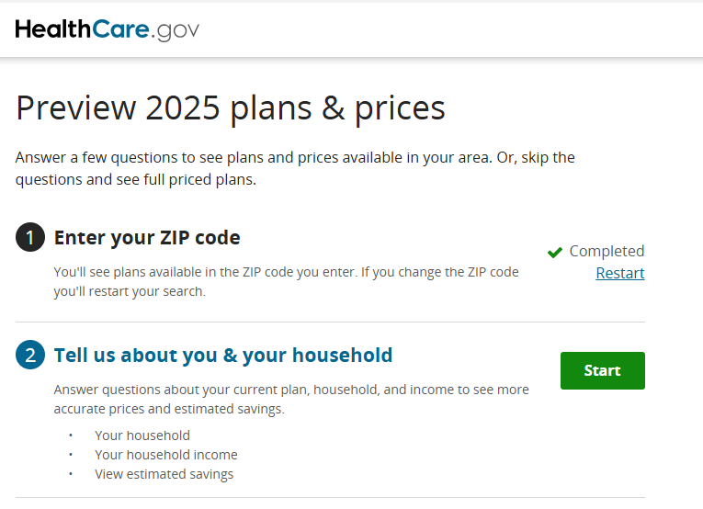
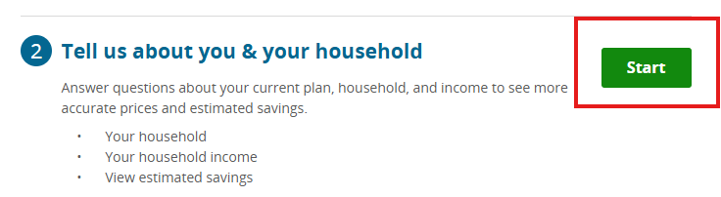

Question: “Who’s in your household?”
Your household includes:
- You
- Your spouse (if married)
- Anyone you’ll claim as a dependent on your tax return
Choose:
- “Just you” if you’re the only person in your household
- “You and other people” if you have others (like spouse or children)

Example: For a family of 3 (you, your spouse, and a child), choose “You and other people” and click Continue.
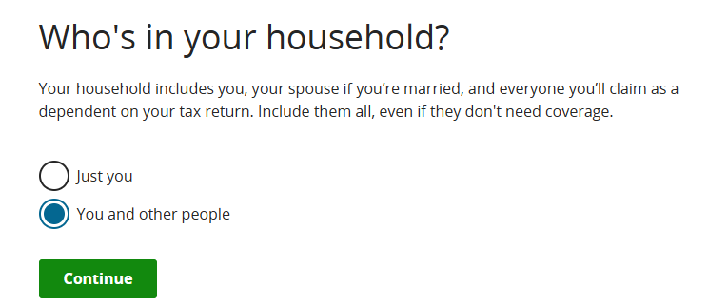

Question: “Are you married?”
- Yes if legally married
- No if divorced, legally separated, unmarried and living together, or widowed
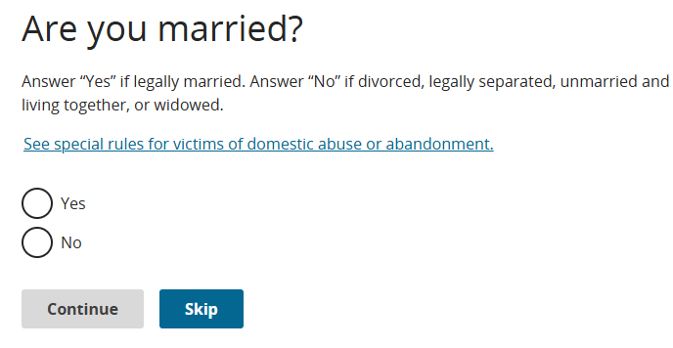
Example: Select Yes if married, then click Continue.
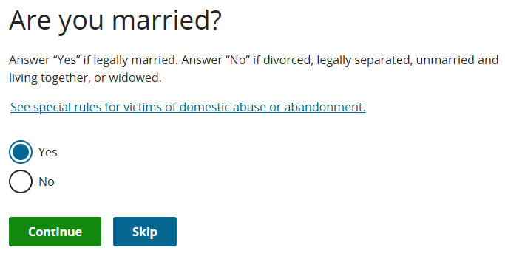

Question: “Will you claim any dependents on your federal tax return?”
Include anyone you’ll claim as a tax dependent in 2026, even if they don’t need coverage. Don’t count yourself or your spouse as dependent.

- Choose Yes and enter the number of dependents (for example, 1 for one child).
- Choose No if you don’t claim dependents.
- Click Continue.

Example: If you have one child, select Yes, enter 1, then click Continue.
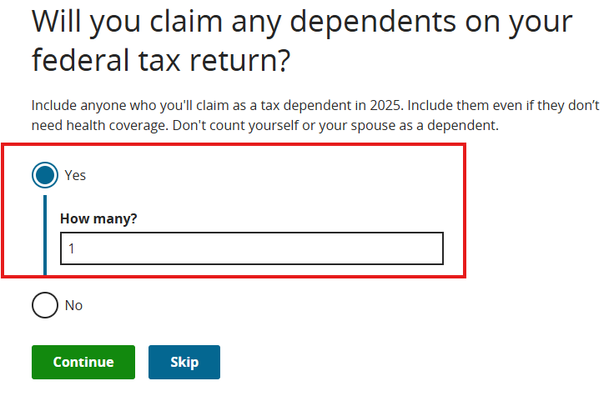

Step 5: Provide Details About Each Person
You’ll now be asked for information about yourself (and later, your spouse and dependents).

Enter:
- Age
- Sex
- Check any boxes that apply:
  - Eligible for health coverage through a job, Medicare, Medicaid, or CHIP
  - Legal parent or guardian of a child under 19 (claimed as a tax dependent)
  - Pregnant (do not include a baby as a dependent until it’s born)
  - Tobacco user (used tobacco products 4 or more times per week on average during the past 6 months (not including ceremonial uses)
  - None of these

Click Continue after completing this section.
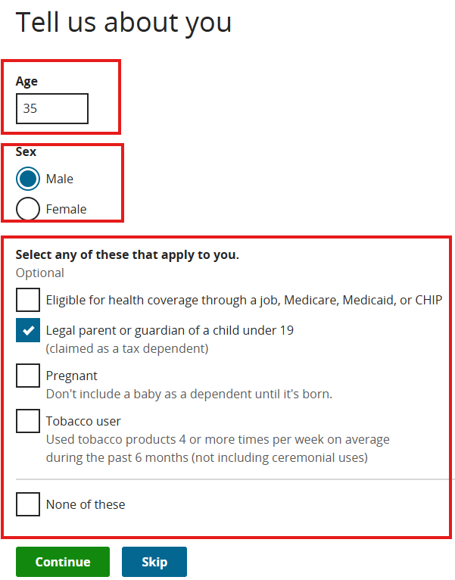
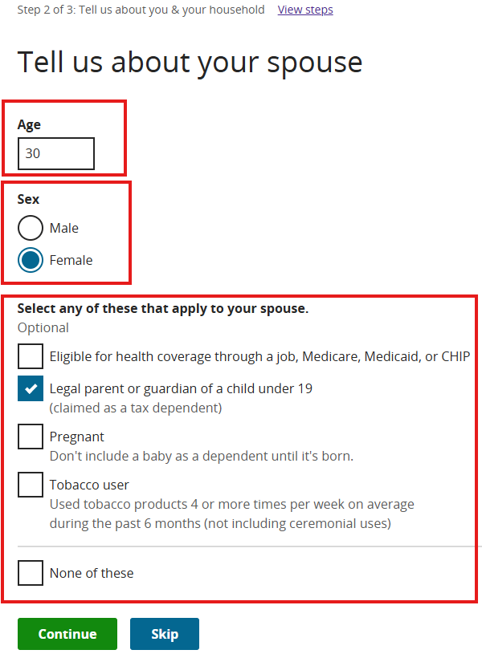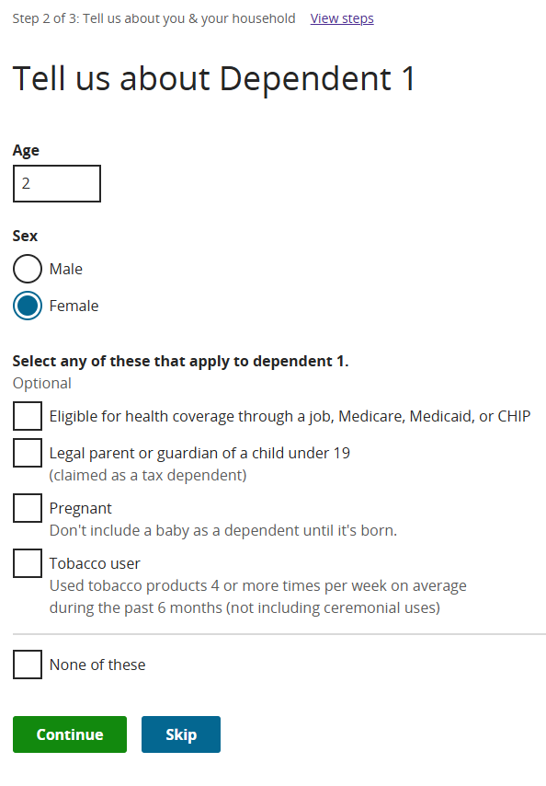

Step 6: Confirm Your Household Information
You’ll see a summary screen showing what you entered. Double-check the details.
- If everything looks correct, click Confirm.
- If you need to fix something, click Edit.

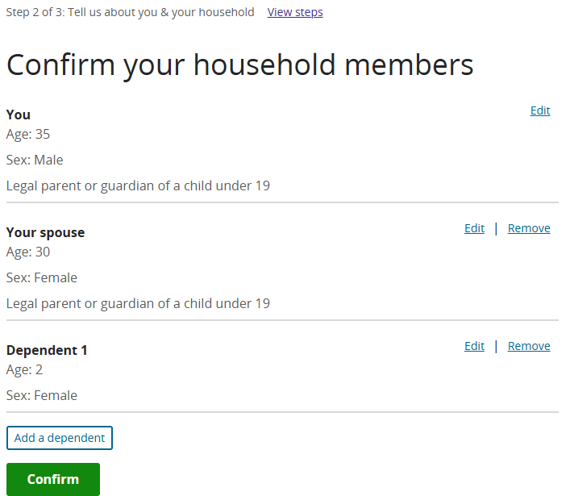

Step 7: Estimate Your 2026 Income
Next, you’ll be asked to enter your expected income for 2026. (If the site still shows 2025, don’t worry — it will update soon.) If you need help estimating, click “See how to estimate your 2025 income” (highlighted in yellow below).
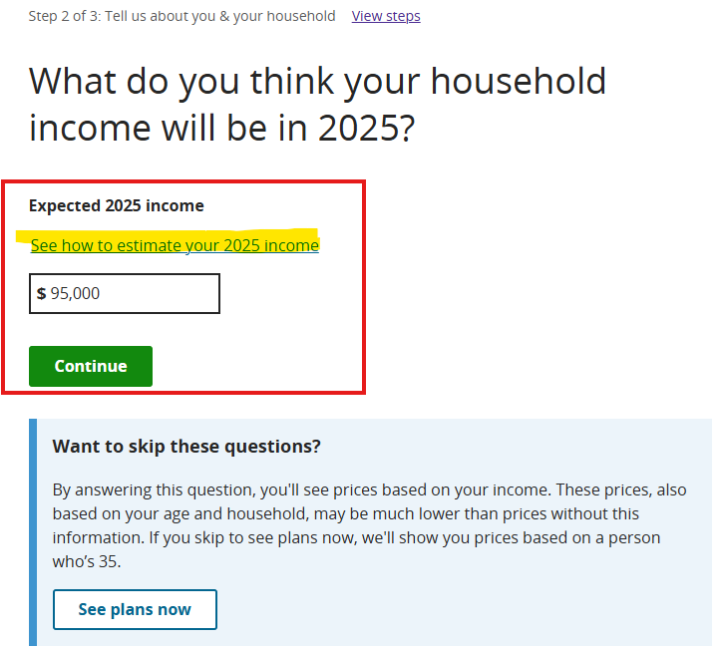

How to estimate your income
Note:
- Marketplace savings are based on your expected household income for the year you want coverage, not last year’s income.
- Income is counted for you, your spouse, and everyone you'll claim as a tax dependent on your federal tax return. Include their income even if they don’t need health coverage.

Step 1. Start with your household’s adjusted gross income (AGI) from your most recent federal income tax return. Don’t have a recent AGI? You can start this estimate using your gross income before taxes are taken out. Or use “federal taxable wages” from your pay stub.

Step 2. Add the following kinds of income, if you have any:
- Tax-exempt foreign income
- Tax-exempt Social Security benefits (including Tier 1 railroad retirement benefits)
- Tax-exempt interest

Don’t include Supplemental Security Income (SSI).

Step 3. Adjust your estimate for any changes you expect.
Consider the following for all members of your household:
- Expected raises
- New jobs or other employment changes, including changes to work schedule or self-employment income
- Changes to income from other sources, like Social Security or investments
- Changes in your household, like gaining or losing dependents

Estimating unpredictable income
It’s hard to predict your income if you’re unemployed, self-employed, on commission, or on a work schedule that changes regularly.
You can base your estimate on your past experiences, recent trends, what you know about possible changes at your workplace, and similar information. Just do your best so you get a realistic estimate of your Marketplace savings.
Click on continue once you add the income.
The next screen will give you an idea of the estimated savings you may be eligible for as a premium tax credit. What this means is that your monthly premium can be reduced by this amount.

Step 8: View Your Savings and Plan Options
The next screen will show your estimated savings — also called a premium tax credit. This tells you how much your monthly cost could be reduced.
Click “View plans” option. You’ll now see all the plans available in your area.

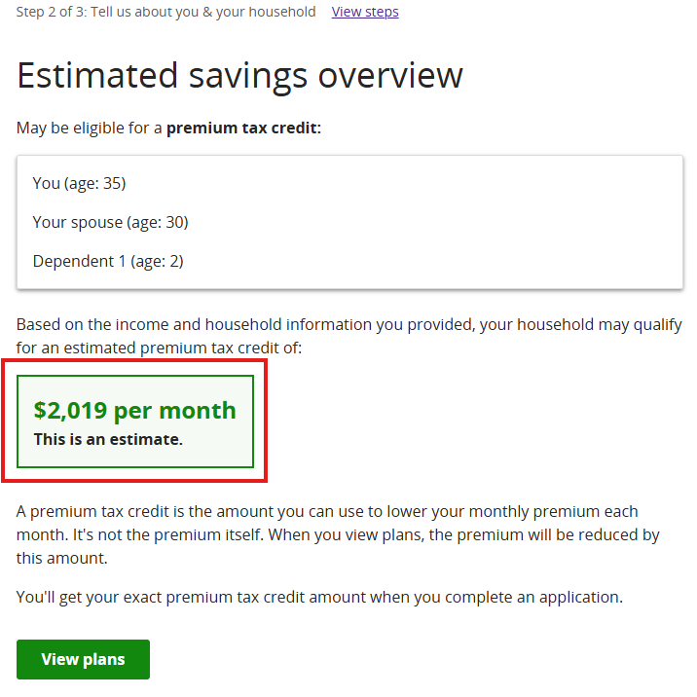

Step 9: Review Available Plans
You’ll see a list of health plans. By default, they are sorted by the lowest premium first.
Example: A plan may show:
- Premera Blue Cross Preferred Bronze 5800 HSA
- Monthly cost: $3 (after applying your savings)
- Original cost: $1,816.79
- Because of your premium tax credit, you only pay $3/month.

Each plan summary shows:
- Deductible
- Out-of-pocket maximum
- Visit costs (primary care, specialists, etc.)

To learn more, click “Go to plan details.”
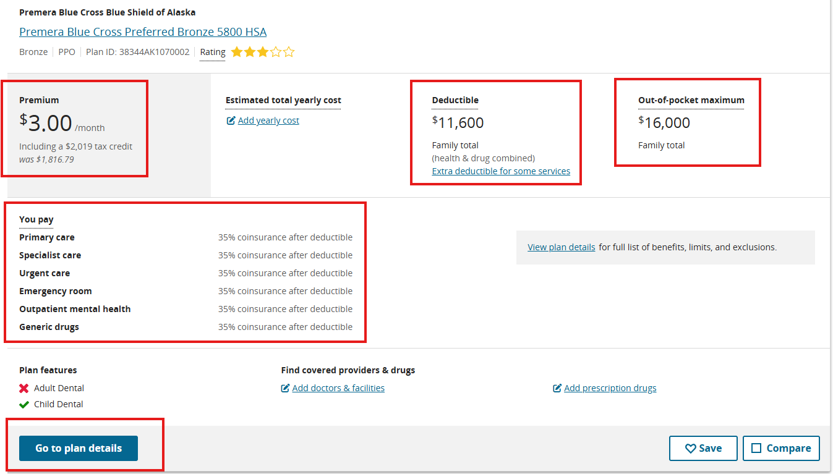

To see Dental Plans:
- At the top of the plan results page, find the “Plan type” dropdown menu.
- By default, it shows “Health Plans”.
- Click the dropdown and select “Dental” to view dental plan options instead.
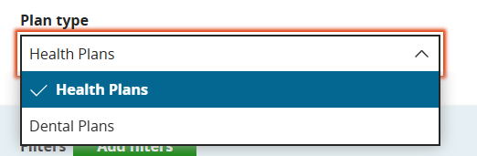

Step 10: Check Provider Networks
Before choosing a plan, review which providers are covered (in-network). If your doctor is not in-network, you may have to pay more out of pocket.
Refer to our education materials for help understanding:
- Common insurance terms
- What “in-network” and “out-of-network” mean
- How cost-sharing works

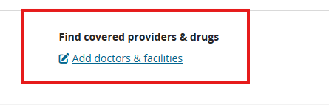

Step 11: Explore More Plans
Scroll down to view all available options. Compare costs, coverage, and provider networks to find what fits best for you and your family’s needs — including dental coverage if needed (you can change “Plan type” to view Dental plans).

Step 12: Compare Plans
You can compare different Marketplace plans by using the “Compare” feature. Under each plan, check the box labeled “Compare” to add it to your comparison list. You can compare up to three plans at a time. Take note of the plan names you want to review, especially if you plan to come back later or discuss them with a navigator or counselor. Once selected, click “Compare” to see a side-by-side view of key details like monthly premiums, deductibles, copays, and coverage levels.
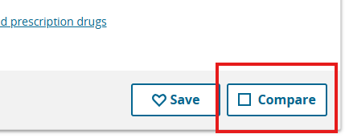
Viewing the Side-by-Side Comparison
Once you have selected the plans you want to compare:
- At the top of the page, you’ll see an option that says “Compare X Plans”, where X is the number of plans you selected. Click on it.

- For example, if you selected one Bronze plan, one Silver plan, and one Gold plan, you’ll see a side-by-side comparison of all three.

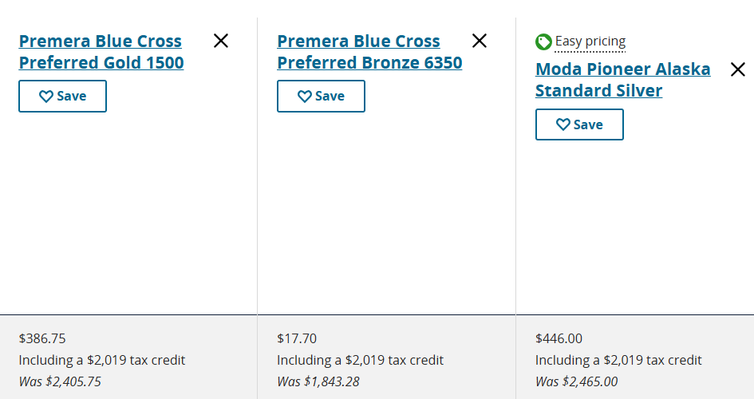
- The comparison highlights key differences between the plans, including:
  - Monthly premium
  - Deductible
  - Out-of-pocket maximum
  - Plan type (PPO, EPO, POS)

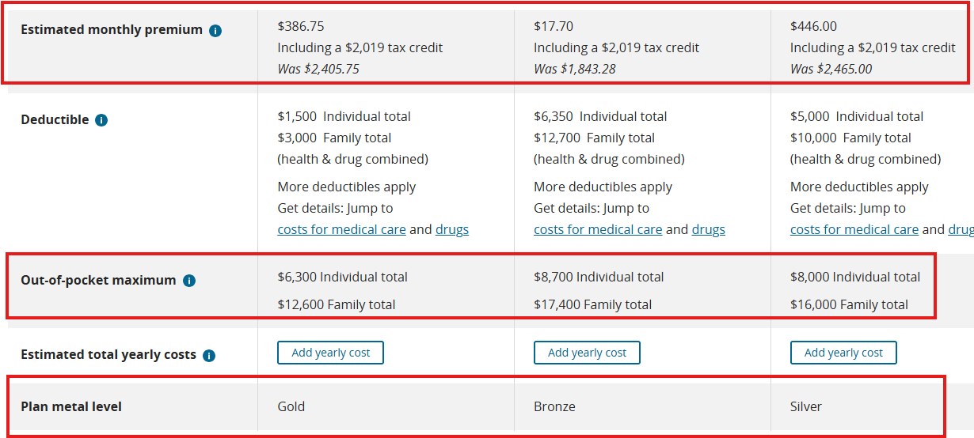

- Scroll down to the Medical Providers In-Network section to check if your preferred doctors and clinics are listed.
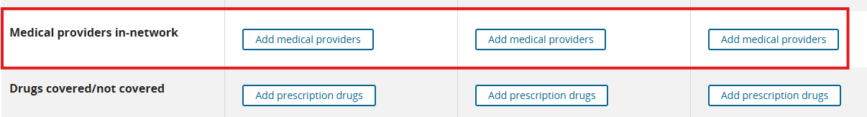
- Further down, you’ll see “Costs for Medical Care.” This section provides detailed estimates of what you might pay for services and prescriptions. Reviewing these numbers can help you choose the plan that is right for you and your family.
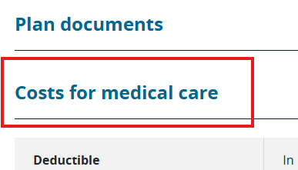

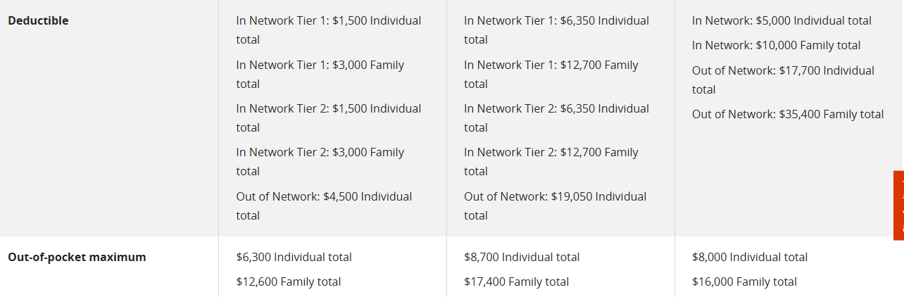
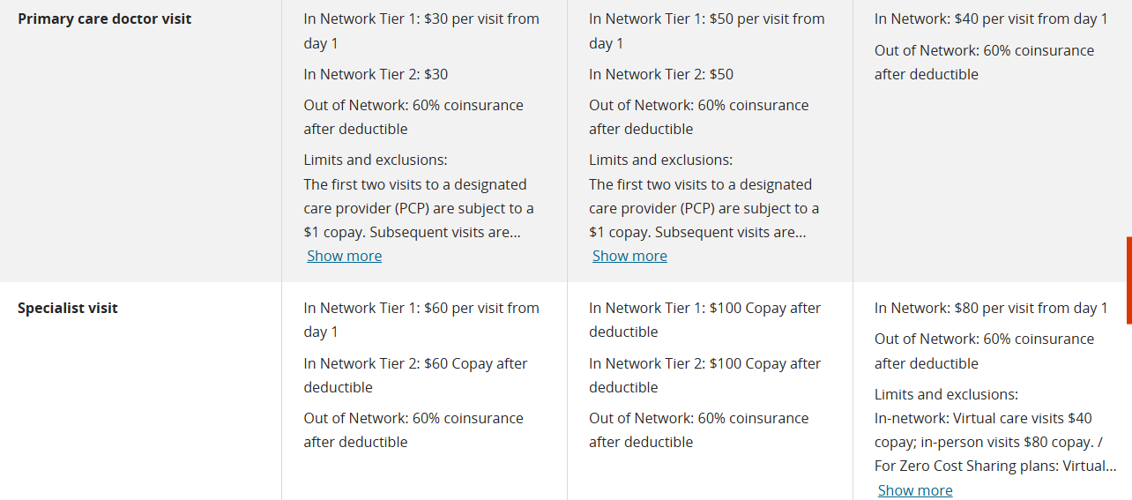

Step 13: Finalize your Plan choice
After comparing your options, take note of the plan that best fits the needs of you and your family.
- Use the “Compare” checkbox under each plan to review up to three plans at a time.
- Make sure to write down the plan names you want to compare or consider for enrollment.
- Reviewing your selected plans side-by-side helps you see differences in monthly premiums, deductibles, out-of-pocket costs, plan type, and provider networks.

This step ensures you’re prepared to enroll in the plan that works best for your family.

