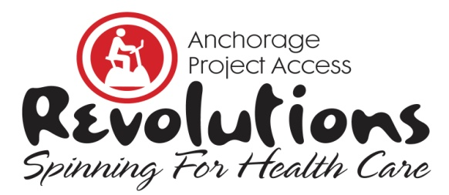

11th Annual Fundraiser | February 8, 2020

Anchorage 5th Avenue Mall | 10 AM to 3 PM

Sponsorship Form 2020
Yes, my company would be proud to sponsor Revolutions, Spinning for Health Care.

Indicate below your level of sponsorship, complete contact information, and payment option. Mail, Fax or Scan sponsorship form to Anchorage Project Access before January 15, 2020.

For more event information and sponsorship opportunities, visit AnchorageProjectAccess.org, email Development@AnchorageProjectAccess.org or call 907-529-6458.

- Premier Sponsor $10,000
- Champion for Project Access $5,000
- Partner in Health $2,500
- Friend of Medicine $1,500
- Thoughtful Giver $500
- Rider Sponsor $250

Contact Information | Please Print all Information
Company

Contact Person & Title

Phone

Fax

Email

Web Address

Mailing Address

Payment Options | Amount of Donation $_____________________  - Check enclosed. Make check payable to Anchorage Project Access.  - Call me and I’ll provide credit card information  - Credit Card: ___Visa ___Mastercard ___Discover ___American Express  Credit Card# __________________  _  Expiration Date __ CVV ___ Zip ____________ _  Print Name on Card __________________  Authorized Signature ________________ _
Anchorage Project Access is a 501(c)(3) Charitable Organization. Tax ID #92-0152088
Revised 08.05.19

THANK YOU FOR YOUR SUPPORT!

Anchorage Project Access • 2401 East 42nd Avenue, Suite 104 • Anchorage, AK 99508
P: (907) 743-6600 • F: (907) 646-0542 • AnchorageProjectAccess.org

