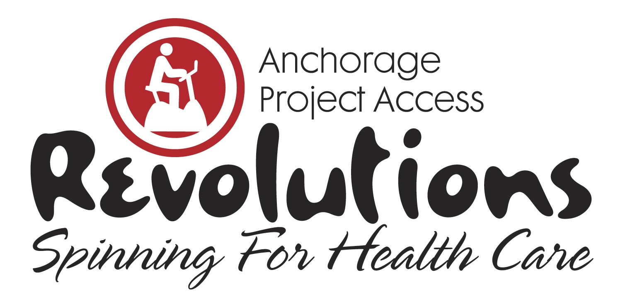
11th Annual Fundraiser
Saturday, February 8, 2020
Anchorage 5th Ave Mall
10 AM- 3 PM

I am participating in the 11th Annual Revolutions, Spinning for Health Care fundraiser for Anchorage Project Access and I need your support to meet my financial goal. Together, we can make a difference! Riders solicit donations and spin for an hour in a spirit of both friendly competition and shared commitment to APA’s mission of increasing access to donated medical and dental care to low-income, uninsured individuals in our community. Funds raised are specifically for patient benefits and case management for enrolled patients. With the generosity of local medical and dental providers, Anchorage Project Access has coordinated over $47.7 million in donated specialty medical and dental care in Anchorage.

In 2018 Anchorage Project Access (APA) coordinated over $1.8 million in donated health care and helped over 430 people access health insurance. Since 2005, APA has coordinated over 17,000 appointments for over 3,550 patients who have received an average of 4 or more specialty treatment services per patient to help people return to work and achieve renewed health. All patients establish a primary care health home for ongoing care. APA helps people access donated medical and dental care, enroll in health insurance and learn about all aspects of health insurance and accessing care.
Please help me support Anchorage Project Access as they strive to provide residents with access to quality health care services during their time of need by making a donation.

To make a donation online, go to AnchorageProjectAccess.org, then click 2020 Official Team and Rider List to designate your donation in my name. If you prefer, complete the enclosed Donation Form and mail or fax to Anchorage Project Access at the address below.

Together we can make a difference in our community.

Sincerely,

Anchorage Project Access ♦ 2401 E 42nd Avenue Suite 104 ♦ Anchorage, AK 99508
Phone (907)743-6600 ♦ Fax (907)646-0542 ♦ AnchorageProjectAccess.org
development@anchorageprojectaccess.org

