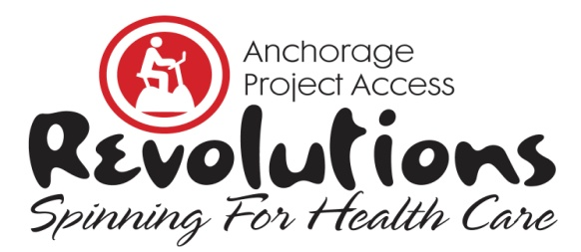

11th Annual Fundraiser | February 8, 2020

Anchorage 5th Avenue Mall | 10 AM to 3 PM

Donation Form 2020
Yes, I want to make a donation for Revolutions, Spinning for Health Care to benefit the patients of Anchorage Project Access.

Please indicate your donation type below, complete all contact information and payment options.
Mail, Scan or Fax completed Donation Form by February 2, 2020.

□ Designated donation for individual rider who is raising funds for this event.
Rider’s Name ____________________________ Team ____________________
□ General Donation
□ Sponsorship (indicate level) ***where will the donor find the levels if they just access this one form??

Contact Information | Please Print All Information
Name
Company
Phone
Email
Web Address
Address
Payment Options | Amount of donation $ _________  □ Check enclosed. Make check payable to Anchorage Project Access  □ Call me and I’ll provide credit card information.  □ Credit Card: __Visa __ MasterCard __ Discover  Credit Card # _____________________________________________  Expiration Date ______________ Three-Digit ___________________  Print Name on Card ________________________________________  Authorized Signature _______________________________________

(Anchorage Project Access is a 501(c)(3) listed under Christian Health Associates). Tax ID #92-0152088.
Revolutions, Spinning for Health Care is a fundraiser for Anchorage Project Access that will be held on Saturday, February 8, 2020, at the Anchorage 5th Avenue Mall. It’s a spinning FUNdraiser in which teams & individuals participate in an hour of spinning to raise awareness and funding for Anchorage Project Access. Riders solicit donations and spin for an hour in a spirit of both friendly competition and shared commitment to support Anchorage Project Access’ mission of increasing access to health care for low-income, uninsured individuals.

Anchorage Project Access ♦ 2401 East 42nd Avenue Suite 104 ♦ Anchorage, AK 99508
Phone (907)743-6600 ♦ Fax (907)646-0542 ♦ development@anchorageprojectaccess.org ♦ AnchorageProjectAccess.org
THANK YOU FOR YOUR SUPPORT!

