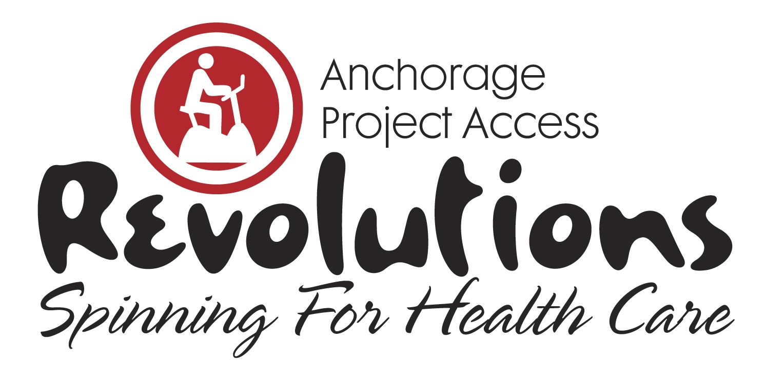

2019 Revolutions Sponsorship Form
Yes, my company would be proud to sponsor Revolutions, Spinning for Health Care.

Instructions: Indicate below your level of sponsorship, complete contact information and payment option. Mail or fax sponsorship form to Anchorage Project Access before February 1, 2019.

For more event information and sponsorship opportunities, visit AnchorageProjectAccess.org, email kholta@anchorageprojectaccess.org or call 688-1009.

Event Benefactor…………………………. $5,000

Partner in Health………………………… $2,500

Champion for Access……………….…… $1,500

Friend of Medicine……………………….. $ 500

Thoughtful Giver…………………………. $ 250

Contact Information | Please Print all Information
Company
Contact Person & Title
Phone
Fax
Email
Web Address
Mailing Address
Payment Options | Amount of Donation $_____________________  Check enclosed. Make check payable to Anchorage Project Access.  Call me and I’ll provide credit card information  Credit Card: ____Visa ____Mastercard _____Discover  Credit Card#_________________________________________  Expiration Date_______________Three-Digit______________  Print Name on Card___________________________________  Authorized Signature___________________________________

Anchorage Project Access is a 501(c)(3) Charitable Organization. Tax ID #92-0152088

THANK YOU FOR YOUR SUPPORT!

Anchorage Project Access • 2401 E 42nd Avenue, Suite 104 • Anchorage, AK 99508
PH: (907) 743-6600 • FAX: (907) 646-0542 • AnchorageProjectAccess.org

