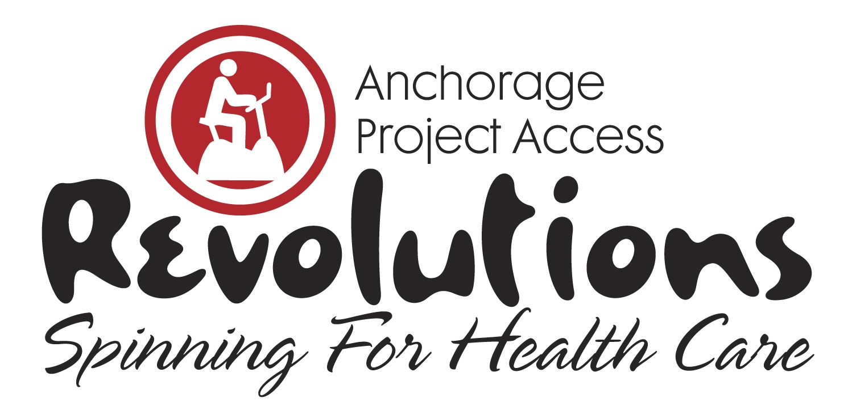

I am participating in the Revolutions, Spinning for Health Care fundraiser and need your support to meet my financial goal. Together, we can make a difference.

Revolutions, Spinning for Health Care is a fundraiser for Anchorage Project Access (APA) that will be held on Saturday, February 9, 2019, 11am-4pm, at the Anchorage 5th Avenue Mall. It’s an exciting stationary biking event in which teams compete to raise awareness and funding for APA. Riders solicit donations and spin for an hour in a spirit of both friendly competition and shared commitment to APA’s mission of increasing availability of health and dental care to low income uninsured patients; funds raised are specifically for medication assistance and case management for enrolled patients. As Anchorage Project Access completes its 13th year of operation over $45 million in donated care has been documented.

Please help me support Anchorage Project Access as they strive to provide residents with access to quality health care services during their time of need by making a donation.

Make a donation online at AnchorageProjectAccess.org; be sure to designate your donation in my name. If you prefer, complete the enclosed Donation Form and mail or fax to Anchorage Project Access at the address below.

Together we can make a difference in our community.

Sincerely,

Anchorage Project Access ♦ 2401 E 42nd Avenue Suite 104 ♦ Anchorage, AK 99508
Phone (907)743-6600 ♦ Fax (907)646-0542 ♦ AnchorageProjectAccess.org

