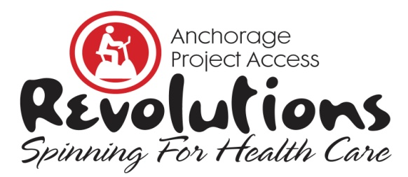
Revolutions, Spinning for Health Care is a fundraiser for Anchorage Project Access that will be held on Saturday, February 9, 2019 at the Anchorage 5th Avenue Mall. It’s a spinning relay in which teams compete to raise awareness and funding for Project Access. Riders solicit donations and spin for an hour in a spirit of both friendly competition and shared commitment to the Project Access mission of increasing availability of healthcare to uninsured patients; funds raised are specifically for medication assistance and case management for enrolled medical & dental patients.

Rider Donation Form 2019

For Rider ____________________________________________
Team Name __________________________________________
Captain’s Name _______________________________________

Donor Instructions: Please provide all contact information below; indicate amount and method of payment. If you prefer to pay with credit card, donations can be made online at AnchorageProjectAccess.org; indicate amount below and √ Online Donation Commitment. Be sure to designate the rider’s name when making an online donation; rider will be notified.

Rider Instructions: Deadline for team sign up is February 2, 2019. Deadline for completed Rider Donation Form to your team captain is February 5, 2019.

Name | Address | City | State | Zip | Phone | Amount Donated and Method of Payment | Office Use Received/ Verified
 |  |  |  |  |  | $ _________ □ Check #________ □ Cash □ Online Donation Commitment
 |  |  |  |  |  | $ _________ □ Check #________ □ Cash □ Online Donation Commitment
 |  |  |  |  |  | $ _________ □ Check #________ □ Cash □ Online Donation Commitment
 |  |  |  |  |  | $ _________ □ Check #________ □ Cash □ Online Donation Commitment
 |  |  |  |  |  | $ _________ □ Check #________ □ Cash □ Online Donation Commitment
 |  |  |  |  |  | $ _________ □ Check #________ □ Cash □ Online Donation Commitment
 |  |  |  |  |  | $ _________ □ Check #________ □ Cash □ Online Donation Commitment
 |  |  |  |  |  | $ _________ □ Check #________ □ Cash □ Online Donation Commitment
 |  |  |  |  |  | $ _________ □ Check #________ □ Cash □ Online Donation Commitment
 |  |  |  |  |  | $ _________ □ Check #________ □ Cash □ Online Donation Commitment
 |  |  |  |  |  | $ _________ □ Check #________ □ Cash □ Online Donation Commitment
 |  |  |  |  |  | $ _________ □ Check #________ □ Cash □ Online Donation Commitment
 |  |  |  |  |  | $ _________ □ Check #________ □ Cash □ Online Donation Commitment
Anchorage Project Access ♦ 2401 E 42nd Avenue Suite 104 ♦ Anchorage, AK 99508 ♦ Phone (907)743-6600 ♦ Fax (907)646-0542 ♦ AnchorageProjectAccess.org

