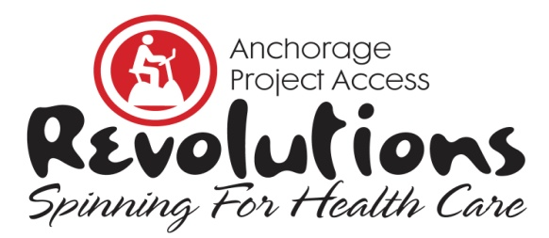
Donation Form 2018
Yes, I want to make a donation for Revolutions, Spinning for Health Care.

Instructions: Please indicate your donation type below, complete all contact information and payment options. Mail or fax completed Donation Form by January 31, 2018.

□ Designated donation for individual rider who is raising money for this event.
Rider’s Name ____________________________ Team ____________________
□ General Donation
□ Sponsorship

Contact Information | Please Print All Information
Name
Company
Phone
Fax
Email
Web Address
Address
Payment Options | Amount of donation $ _________  □ Check enclosed. Make check payable to Anchorage Project Access  □ Call me and I’ll provide credit card information.  □ Credit Card: __Visa __ MasterCard __ Discover  Credit Card # _____________________________________________  Expiration Date ______________ Three-Digit ___________________  Print Name on Card ________________________________________  Authorized Signature _______________________________________
(Anchorage Project Access is a 501(c)(3) Charitable Organization). Tax ID #92-0152088.

Revolutions, Spinning for Health Care is a fundraiser for Anchorage Project Access that will be held on Saturday, February 3, 2018, at the Anchorage 5th Avenue Mall. It’s a spinning relay in which teams compete to raise awareness and funding for Project Access. Riders solicit donations and spin for an hour in a spirit of both friendly competition and shared commitment to the Project Access mission of increasing availability of health care to uninsured patients; funds raised are specifically for medication assistance and case management for enrolled medical and dental patients.

Anchorage Project Access ♦ 2401 East 42nd Avenue Suite 104 ♦ Anchorage, AK 99508
Phone (907)743-6600 ♦ Fax (907)646-0542 ♦ AnchorageProjectAccess.org

THANK YOU FOR YOUR SUPPORT!

